from wiki

there will be:

1 King (The king takes the vacant spot next to the queen)

1 Queen (queen is placed on the central square of the same color of

that of the player: white queen on the white square and black queen on black square.)

2 Rock (rooks are placed on the outside corners, right and left

edge.)

2 Bishop (bishops are placed immediately inside of the knights.)

2 Knight (knights are placed immediately inside of the rooks.)

8 Pawns ( pawns are placed one square in front of all of the other

pieces.)

**Bishop:** one of two pieces of the same color that may be moved any number squares diagonally, as long as no other piece blocks its way. One piece always remains on White squares and the other always on Black.

**Castling:** to move the king two squares horizontally and bring the appropriate rook to the square the king has passed over.

**Check:** To make a move that puts the opponents King under direct attack.

**Checkmate**: a situation in which an opponent’s king is in check and it cannot avoid being captured. This then brings the game to a victorious result.

**Chess Board**: A board you need to play Chess. Have 64 black and white square.

**Chess**: A game played by 2 people on a chessboard with 16 pieces each.

**En Passant**: a method by which a pawn that is moved two squares can be captured by an opponent's pawn commanding the square that was passed

**King:** The main piece of the game, checkmating this piece is the object of the game. It can move 1 space in any direction.

**Knight:** This piece can move 1 space vertically and 2 spaces horizontally or 2 spaces vertically and 1 space horizontally. This piece looks like a horse. This piece can also jump over other pieces.

**Pawn:** One of eight men of one color and of the lowest value usually moved one square at a time vertically and capturing diagonally.

**Player or user**: A user or a player will be the person that is playing the chess game.

**Queen**: This piece can move in any number of spaces in any direction as long as no other piece is in its way.

**Rook:** one of two pieces of the same color that may be moved any number squares horizontally or vertically, as long as no other piece blocks its way.

**Stalemate:** A situation in which a player’s king is not in check, but that player can make no move. This then results is a stalemate, which is a draw.

Basic Move

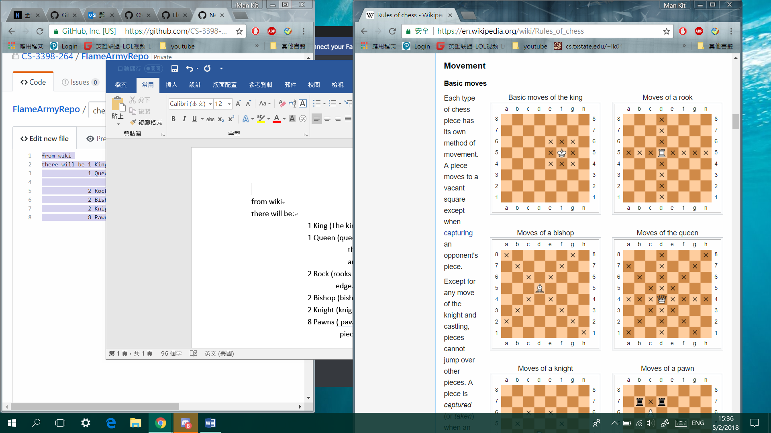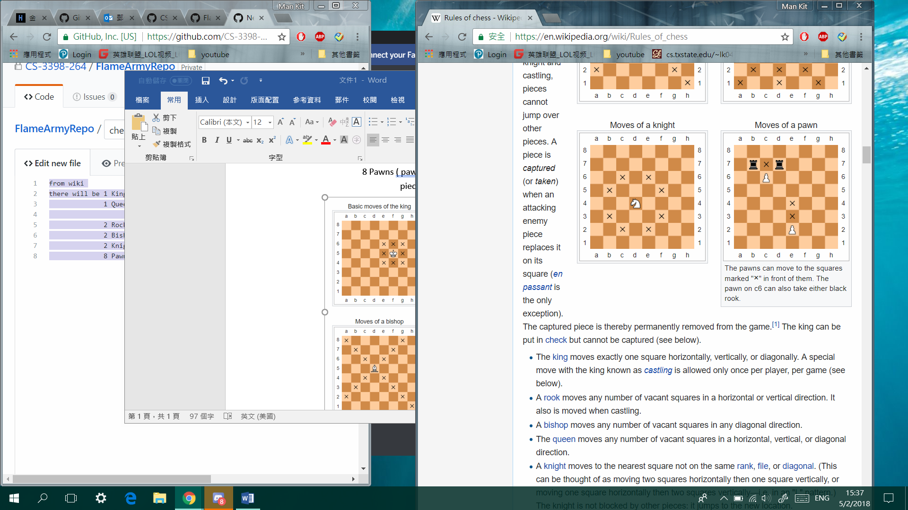

Special condition on move:

Casting: (move between KING and ROCK )

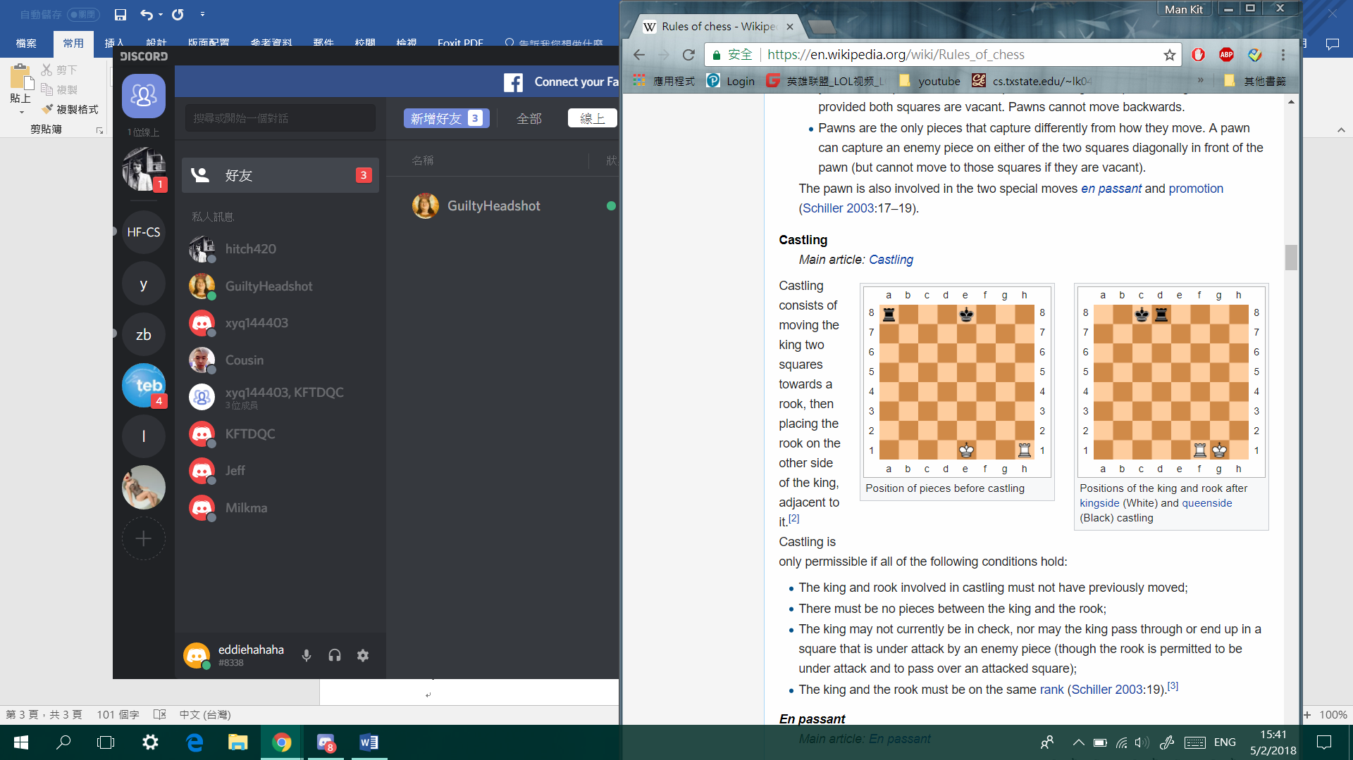

En Passant and Promo (move about PAWN)

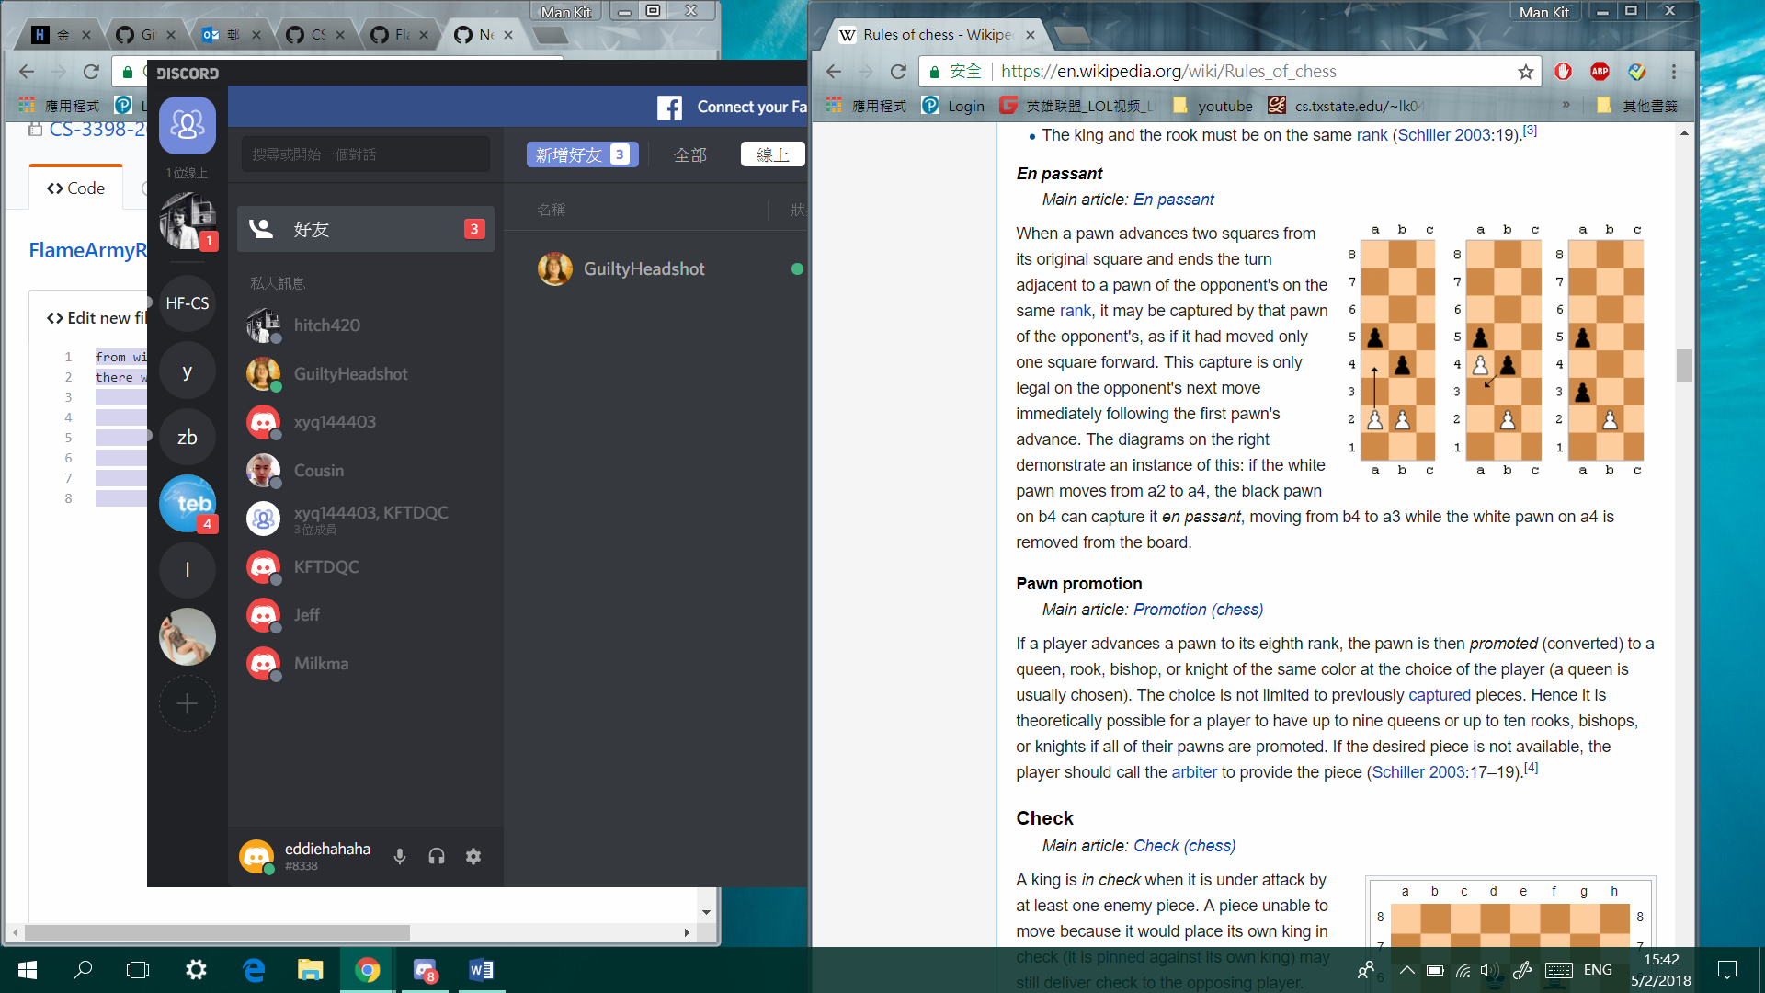

Check: (When KING is about to be taken)

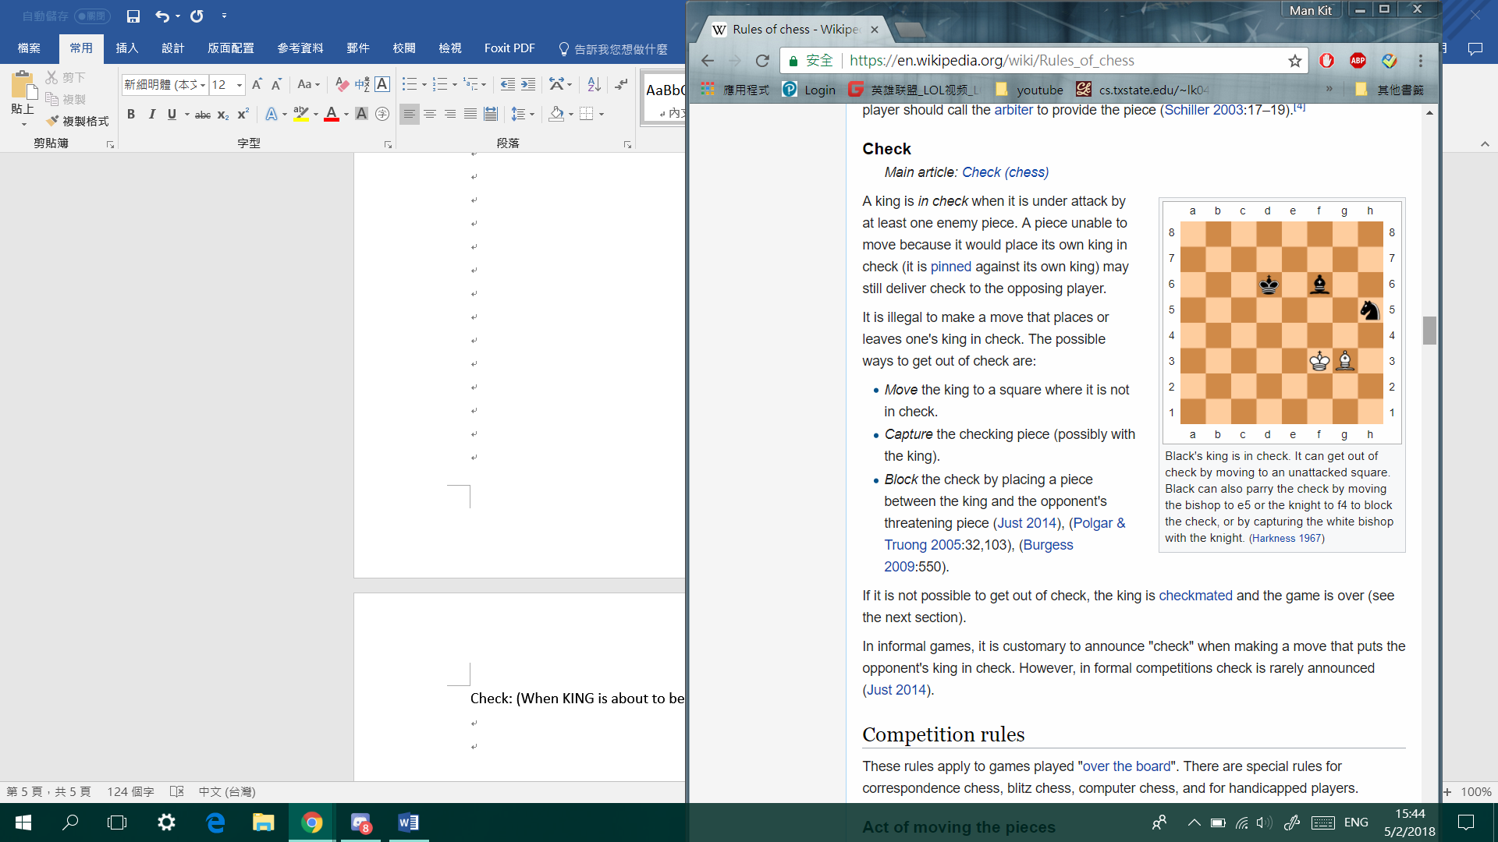

Recording moves

